# Elevate Your Kitchen With Cherry Cabinets

**Cherry** is an incredibly versatile hardwood that looks beautiful in a variety of **kitchen cabinet styles**. Its distinctive grain patterns make it a classic choice for those who love the comfort and warmth of **wood cabinets**.

However, while many people think of **cherry** as a dark and outdated choice, there are some great ways to bring it into a modernized design. Read on to learn how!

## Why Cherry Cabinets Are a Great Choice

If you are looking to give your **kitchen** a contemporary makeover, then consider **updating your cabinets** with some modern features. A simple paint job or replacing your countertops with a sleek and modern material such as quartz are easy ways to make a huge difference in your space without breaking the bank!

Another popular way to **update your cabinets** is by replacing them with open shelving. This is a trendy **trend in kitchen design** and will create a fresh and modern look that works perfectly with your cherry cabinets!

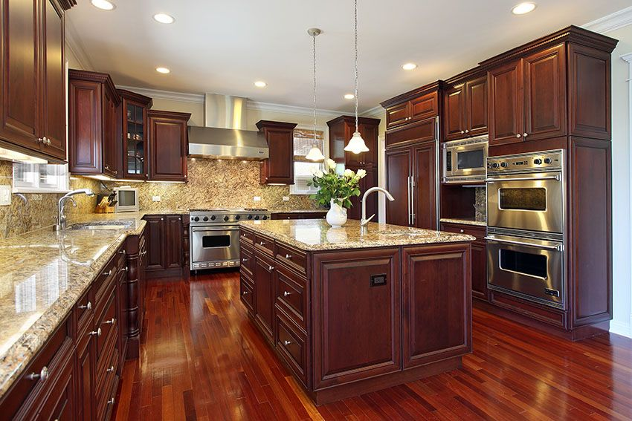

One of the primary reasons that homeowners choose to **purchase Cherry Cabinets** for their kitchen is because they are aesthetically pleasing. The rich color and deep undertones of this wood add a luxurious look to the room, making it more inviting and comfortable for family and friends.

Furthermore, this type of wood is light sensitive and will darken and ripen over time, creating a beautiful patina that increases in depth with age. This characteristic makes **Cherry wood** a favorite for many homeowners, and it’s also one of the most durable types of hardwoods available.

The best way to ensure that your **Cherry Cabinets** stand the test of time is to take proper care of them. Regular cleaning and sealing will help to preserve their appearance and keep them in great condition for years to come. You can also use a stain to enhance the natural **beauty of your cherry cabinets** and add a touch of color!

## Matching Your Cherry Cabinets with Your Countertop

Matching your **countertops** to your **cherry cabinets** is an essential part of creating a beautiful kitchen design. Contrasting **countertop colors** can add depth and drama to your space, while coordinating counter colors create a balanced look.

Whether you’re planning to **install laminate or granite**, it’s important to choose the right color palette for your space. Using the color wheel can help you determine whether you want to blend or contrast.

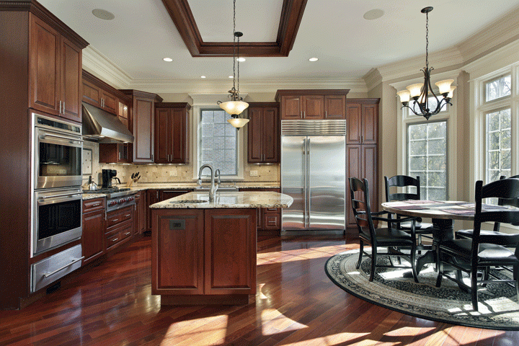

You can also use the hues on the color wheel to determine which paint colors will work best with your **cabinetry**. For instance, light green or blue paints can complement your **dark cherry wood**.

If you want to make your space feel more contemporary, painting your walls a lighter color can be an effective way to brighten the room up. A light color will make the room feel larger and brighter, and it can even be paired with a darker countertop.

The right color can also **improve your lighting** by bringing more natural light into the room. White curtains are another great way to bring more light into your space.

A soft neutral like greige, cream, or beige will also pair well with **cherry wood**. The neutral tones will offset the rich cherry and keep the room looking bright.

## Cherry Cabinet Door Styles

**Cherry** is one of the most sought-after **woods for kitchen cabinets** because it adds value to your home, and also has a classic, elegant look. The fine grain on this **wood** is a great feature that makes it stand out, and also helps keep it durable.

The color of rough sawn Cherry is often a light pink, but over time with UV exposure and oxidation it darkens to a beautiful brownish red. This process can be confusing because it looks very different from the color of unfinished products, but it is a trait that many people find appealing and can be a good reason to choose this **wood for your kitchen**.

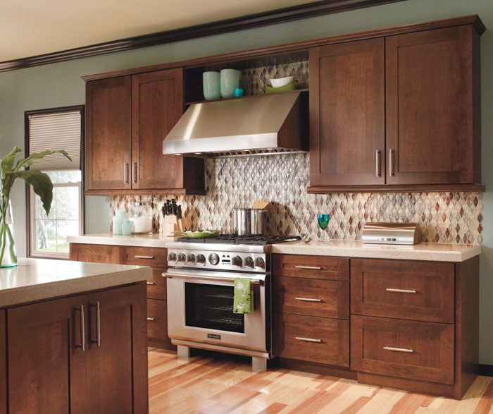

There are several ways to customize your **new Cherry Cabinets**, and one of the most important decisions is what **door style** to choose. There are a few common options, including full overlay (where the doors sit over top of the cabinet box), partial overlay (where the door frames are recessed or flat, which helps make them look smoother) and inset (where the door sits flush with the cabinet frame when closed).

**Shaker doors**, which have been popular for years, offer a clean, traditional look that works well with any style of kitchen. They are a five-piece door that features rails and stiles, making them very versatile.

## Best Hardware for Your Cherry Cabinets

**Cherry wood cabinets** are a great way to elevate your kitchen. They come in a variety of colors and can be customized to fit your style. They are also durable and will increase the value of your home.

If you have **cherry cabinetry**, it's important to choose hardware that will complement the look of your cabinets. This is especially true if you are **updating your cabinets** with new paint or stain.

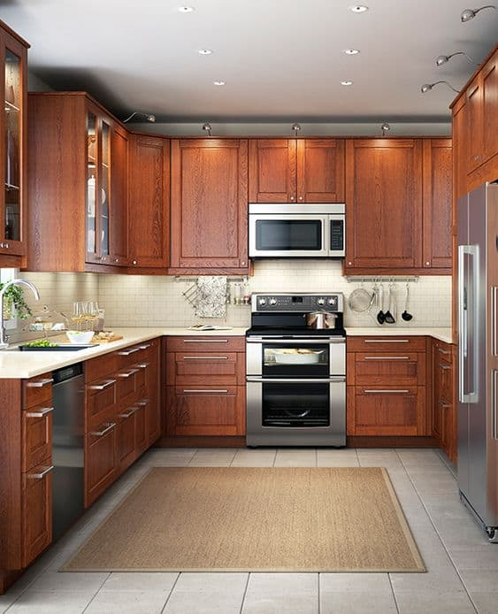

The color of your **hardware** will determine how well your **cabinets** and cabinets hardware blend together. If you want to **modernize your cabinets**, choose handles with cool colors like silver or chrome.

On the other hand, if you'd prefer to keep your **kitchen traditional-styled**, choose handles that have a warm or earthy color. For example, weathered brass handles are often found in traditional-styled spaces and can complement the classic appeal of your cherry cabinets.

Another option is aluminum handles, which are a **great choice for kitchens** because they are fire-resistant. This is particularly important if you have **a gas stove in your kitchen**.

## Lighting Your Kitchen with Cherry Cabinets: Tips

**Dark cherry cabinets** are a common **kitchen trend**. They’re durable and aesthetically pleasing, and they’ll stand the test of time. However, they can also be a challenge to lighten up if you don’t want to replace them.

To **lighten your kitchen**, you can consider painting it a lighter shade of color or adding more lights to the room. You can also add skylights or windows to let in more natural light.

Another great way to **lighten up your kitchen** is to replace dark-colored appliances with lighter ones. These will give your cookhouse a more airy, open feel and complement your beautiful crimson councils.

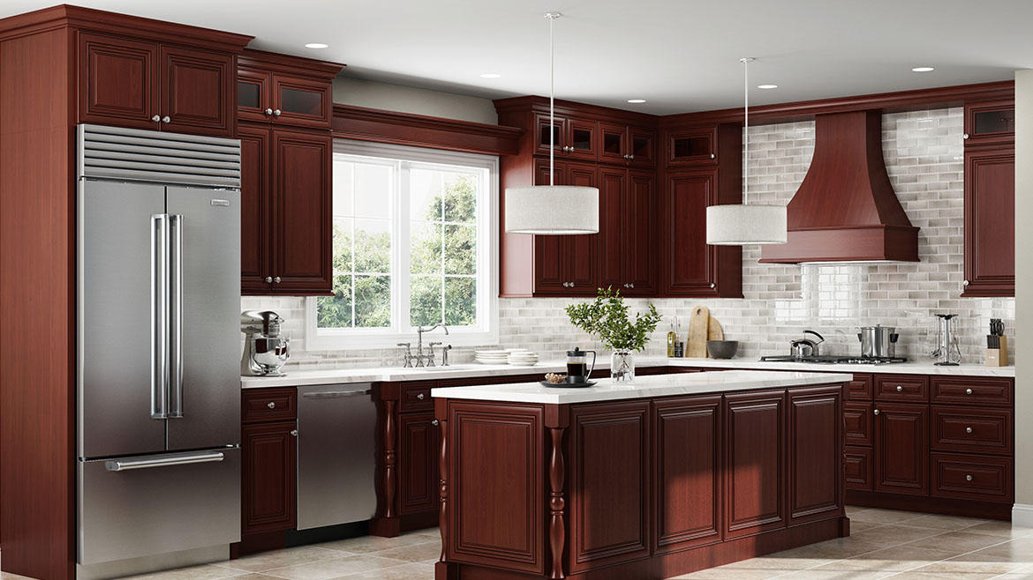

You can also install **under-cabinet lighting** to brighten up your cookhouse and make it more inviting. These lights are easy to install and come in a variety of styles and colors, so you can find one that will match your ruddy councils.

The key to a successful **lightening project** is finding the right solution that’s perfect for your kitchen. It doesn’t have to be expensive, but it should be something that will enhance the look of your **kitchen** without overwhelming it.

Red pairs well with **cherry cabinetry** and provides a fun, bold statement. The contrast of black, however, can be overpowering, so consider using it only as a focal point in your kitchen.

## Accessories to Complement Your Cherry Cabinets

If you want to **elevate your kitchen** with **cherry cabinets**, there are many accessories that you can use to complement them. For example, paint can blend with the **wood** or highlight its natural colors, so it’s important to pick the right color palette.

Another option is to use neutral shades that allow the cabinetry to take center stage. For example, white, off-white, and beige can all look stunning when combined with a dark wood like cherry.

You can also use a **backsplash** that contrasts with the **cabinets** to create an appealing look. For instance, a marble backsplash can provide a sleek look or a **glass tile backsplash** can add a contemporary style.

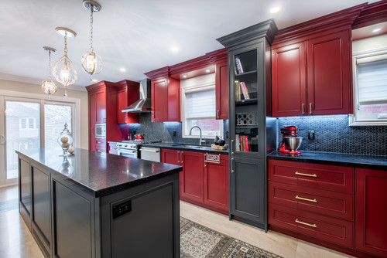

One of the most popular choices for a backsplash is **ceramic tiles**. These are available in a variety of colors and sizes, so you can find the perfect match for your cabinets.

Gray is an on-trend interior color that works well with **cherry cabinets**. However, it’s important to choose a shade that’s just slightly lighter than the cabinets, or it could look too muddy.

Green - **Pairing cherry cabinets** with green is a great way to make a design statement. It can also help the wood pop out more and show its grain more clearly.

If you’re looking for a **stylish countertop** to go with your new cherry cabinets, gold antique granite is a good choice. It’s a **versatile countertop** option that can work well with any **style of kitchen**.

As **In stock Today** Kitchen Cabinets, we meticulously complete your **kitchen remodeling** works with cherry and other different cabinet options.**Contact us** immediately.